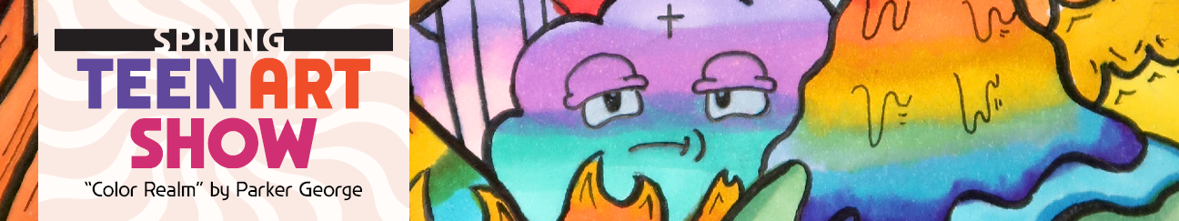Entrants must be between the ages of 16-19 and a Florida resident. Each entrant is limited to three pieces of artwork. **Entries will be accepted from** **February 23 – March 22, 2025**. Artwork must be submitted to one of the 12 Alachua County Library District (ACLD) locations with a completed entry form. Digital artwork must be printed and submitted to one of the 12 ACLD locations.  
  
All artwork must be the original work of the entrant. Entrants must not use AI technology or Machine Learning to generate artwork or to assist in generating artwork.

Artwork should abide by ACLD’s Exhibit and Display Policy found at <https://www.aclib.us/policies>.

Artwork should be labeled with the artist's full name and the title of the piece. Physical artworkmust be no bigger than 18” x 18" x 18".

Video entries must not run longer than five minutes and should contain captions for the hearing impaired. Video submissions must be submitted via email to the Youth Services Department at [ysref@aclib.us](mailto:ysref@aclib.us). Please include the title of the video and artist’s name in the email. Videos can be sent as an mp4 or QuickTime file or can be uploaded to YouTube. Any videos containing copyrighted music may be muted when/if they are shared on the library’s website or other social media sites.   
  
All artworks will be displayed on the library’s website, <https://www.aclib.us/spring-teen-art-show-ages-16-19>, and on the library’s affiliated social media sites, such as Facebook, Twitter, Instagram, Flickr or YouTube for the duration of the show and any extension thereof.

All artworks will be on display to the public at the Headquarters Library on April 5-6, 2025.   
  
Winners will be announced at a reception on **April 5, 2025 at 1:00 p.m.** in the Teen Space at the Headquarters Library, 401 East University Avenue, Gainesville, FL. Winners will be announced via the library’s website no later than Monday, April 7, 2025 by 5:00 p.m. Awards will be given for the following: 1st, 2nd and 3rd Place with four Honorable Mentions, Best Logo, Crowd Favorite and four category winners (Best Painting, Best Portrait, Best Nature, Best Drawing). Decisions of the judges are final. Voting for the Crowd Favorite will be open April 5, 2025 at 1:00 p.m. through April 6, 2025 at 4:00pm. Crowd Favorite will only be announced via the library website.

All artworks must be picked up from the location where it was submitted by **June 8, 2025**. Artwork not picked up by that time will become property of ACLD in accordance with the Gifts to the Library section of the ACLD Collection Development and Maintenance Policy found at <https://www.aclib.us/policies>.

Any questions or concerns can be sent to the Youth Services Department of the Headquarters Library via email at [ysref@aclib.us](mailto:ysref@aclib.us) or by calling 352-334-3941.

Spring 2025 Teen Art Show Entry Form

Entrant’s Legal Name: ____________________­______­­­­­­ Entrant’s Preferred Name: ­­________________

Phonetic Spelling of Entrant’s Name: ______________________________________ Age: ___________

Grade: ___________ School (or Homeschool): _____________________________________________

Entrant’s- Email: _______________________________ Phone Number: ________________________

Parent or Legal Guardian Email and/or Phone: _______________________________________________

Location artwork was submitted/location to collect artwork after show: ____________________________

Number of entries (limited to 3 per artist): _________

Title of Entry 1: ________________________________________________________________________

Materials Used: _______________________________________________________________________

Title of Entry 2: ________________________________________________________________________

Materials Used: _______________________________________________________________________

Title of Entry 3: ________________________________________________________________________

Materials Used: _______________________________________________________________________

By giving permission for (Name of Entrant) _____________________ to enter the Alachua County Library District (ACLD) Teen Art Show, I give permission to display and publish their work on the website and in other media and educational purposes. I understand that their work may be supplied to media outlets which may elect to display and publish their work as well. I understand that they will not be paid for the use of their work. All files and submissions will constitute the property of ACLD and may be used in publications, web publications and other media for purposes of this contest. Entrant retains all other rights to the works.

I affirm that I have read and adhered to all the rules of entry. I affirm that we are Florida residents. I verify that the work submitted is their own creation without assistance of Artificial Intellectual (AI) technology and any other third party. They assume all responsibilities and consequences if their work is found to be otherwise. The Alachua County Library District will not be held responsible if legal action results from publication.

________________________________________ ________________________________

Printed Name of Parent or Legal Guardian Relationship to Entrant

________________________________________ ________________________________

Signature of Parent or Legal Guardian Date Signed

________________________________________ ________________________________

Signature of Entrant Date Signed